Pastor Bob Cloutier

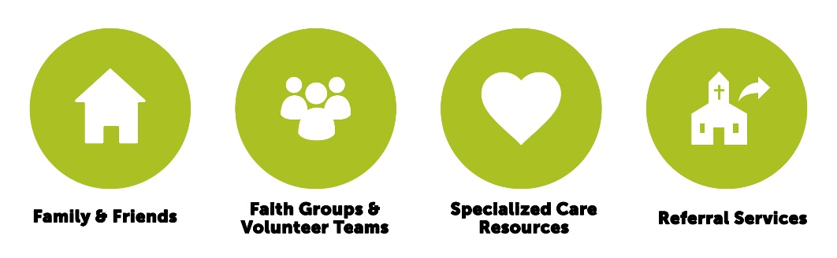
INTRODUCTION
TO
CARE MINISTRY
Updated: August 13, 2019

Pastor Bob Cloutier
Faith Community Church
Table of Contents
Introduction 3
A Biblical Study of Care 4
Hand 4
Know 4
Discipline 4
Good Samaritan 5
Comfort 6
Shepherd 7
Care Ministry Purpose 9
Our Win 9
Our Vision 9
The Four Circles 10
Our Values 12
Our C.A.R.E. Approach 13
Care Organizational Chart 14
Specialized Care Teams 15
Care & Concern (Notes/Gifts) 15
Celebrate Recovery Program 15
Minuteman Movers 15
Money Management Coaching 16
Stephen Ministry 16
Visitation Team 16
Other Care Resources 17
Marriage Mentors 17
Elders Compassion Fund 17
Referral System 17
Pastoral Services 18
Prayer Resources 19
Prayer Requests 19
Sunday Prayer Ministers 19
Urgent/Crisis Needs Prayer List 19
Midweek Prayer Guide 20
Church Intercessory Prayer Groups 20
Other Prayer Groups 20
Foundational Tools 21
Prayer 21
Scripture 22
Next Steps 24
Thank You 25
Care Ministry Application 26

Introduction

Welcome to the Care Ministry!

Thank you for choosing to serve with us. I hope this will be a worthwhile time of service for you. This document will help you understand some of the foundational elements of our Care Ministry and our hopes and dreams for the next few years. Your contribution will be invaluable and worthwhile, so thank you for being part of our team.

A Biblical Study of Care

What is Biblical Care? The Bible uses many words and images when it talks about the type of care God has for His people and His people have for one another.

Hand

One of the most common words used in Hebrew for care is yad. The word literally means “hand” and figuratively means power, strength or control. The idea is that someone is entrusted to care for something or someone else, like when the jailor put everything under the hand of Joseph. It was under his control or power. The psalmist uses this image when he talks about the Lord’s care in Psalm 95:7

“…He is our God and we are the people of his pasture, the flock under his care.”

Biblical care describes us as being under the Lord’s hand, which figuratively means under the power and control of God and surrounded by the strength of God.

Know

Another image of care in the Bible is the word yada. The image means to know or recognize one another. It means to know and make yourself known. It means intimacy and vulnerability. The psalmist wonders in amazement why the God of the universe, a being so large and infinite, is so concerned with beings like us that are small and insignificant. “O Lord, what is man that you care for him.” The proverb writer, Solomon, points to a person who cares for justice and the needs of the poor as a righteous man. The image here is one of relationship and community. The idea is that we see each other as we really are.

Care happens in relationships that are vulnerable and intimate. People are cared for in the context of relationships where you know others and where others know you.

Discipline

A third image is the word paqad. The prophets used this word a lot to describe both the lack of care for God’s people by the leaders, as well as how God would care for His people. The image here is one of attentive authority where leadership and government is concerned for, pays attention to and cares for the people. However, punishment is also an image contained with the word paqad. Zechariah uses this word twice in Zechariah 10:3.

“My anger burns against the shepherds, and I will punish the leaders;
for the Lord Almighty will care for his flock, the people of Judah.”

I will punish the leaders and care for the people – the same word in Hebrew, but a vastly different experience of the Lord’s care. Biblical care therefore contains within it the images of concern and attentions as well as discipline and rebuke.

Care is both comfort and discipline, encouragement and rebuke.

Good Samaritan

These images and a further image are all contained within a well-known parable told by Jesus: the parable of the Good Samaritan. Now, the parable is not focused on teaching us about care; rather it is a pointed story to teach us how to be good neighbors to one another and how to love each other properly, but it is filled with great images of care. Let’s look at it together. Luke 10:25-37:

On one occasion, an expert in the law stood up to test Jesus.
“Teacher,” he asked, “what must I do to inherit eternal life?”
²⁶ “What is written in the Law?” he replied. “How do you read it?”
²⁷ He answered, “‘Love the Lord your God with all your heart and with all your soul and with all your strength and with all your mind’^{[c]}; and, ‘Love your neighbor as yourself.’^{[d]}”
²⁸ “You have answered correctly,” Jesus replied. “Do this and you will live.”
²⁹ But he wanted to justify himself, so he asked Jesus, “And who is my neighbor?”
³⁰ In reply Jesus said: “A man was going down from Jerusalem to Jericho, when he was attacked by robbers. They stripped him of his clothes, beat him and went away, leaving him half dead. ³¹ A priest happened to be going down the same road, and when he saw the man, he passed by on the other side. ³² So too, a Levite, when he came to the place and saw him, passed by on the other side. ³³ But a Samaritan, as he traveled, came where the man was; and when he saw him, he took pity on him. ³⁴ He went to him and bandaged his wounds, pouring on oil and wine. Then he put the man on his own donkey, brought him to an inn and took care of him. ³⁵ The next day he took out two denarii^{[e]} and gave them to the innkeeper. ‘Look after him,’ he said, ‘and when I return, I will reimburse you for any extra expense you may have.’
³⁶ “Which of these three do you think was a neighbor to the man who fell into the hands of robbers?”
³⁷ The expert in the law replied, “The one who had mercy on him.”
Jesus told him, “Go and do likewise.”

A few thoughts about care from this passage:

- The Samaritan sees the man who the thieves robbed. He notices him, recognizes a man in need – the image of yada.
- He is moved by this need within. He has pity or compassion – the image of paqad.
- His does not just feel compassion for the person, he is compelled to act so he bandages him and heals him.
- He sacrifices his own comfort for the comfort of the robbed man.
- He then takes him to an inn and cares for him, even beyond the immediate to the extended care. He leaves money for the man to be cared for placing the man under his care – the image of yad.
- The word in the Greek we translate as “took care,” means, “it is a care to me”. In other words, the robbed man’s need became a burden to the Good Samaritan. He was troubled over his condition and took on the burden of caring for him.

Care takes effort, sacrifice and time. It requires us noticing others, allowing their need to move us to action. Sometimes this sacrifice is out of proportion to our relationship with them and it is costly to us. Care is therefore, generous sacrifice. Care takes ownership of what we see and what moves us. We cannot let it go, so we move towards the need to make a difference.

Comfort

Paul uses yet another image for care when he writes to the Corinthians in 2 Corinthians 1:3-4:

³ Praise be to the God and Father of our Lord Jesus Christ, the Father of compassion and the God of all comfort, ⁴ who comforts us in all our troubles, so that we can comfort those in any trouble with the comfort we ourselves receive from God.

The word for comfort here is a combination of two Greek words – para which means with, or beside or alongside and kaleo which means to call or summon and even to name. Put together, it portrays the image of someone who is asking, begging, pleading, calling for help and help comes in the form of someone who comes alongside him or her. The idea of coming alongside someone is to help him or her stand up in their faith so that they can continue walking in this life. It is not to do their work for them, or walk in their place, but rather it is to help them continue walking and working.

This idea of coming alongside someone in need is so foundational to the Christian life that it is actually one of the names of the Holy Spirit. Jesus calls him the Counselor in John 14, although newer versions of the NIV have changed that word to Advocate. Both words work well. To come alongside someone in need is to advocate for him or her. It is to declare that you are on that person’s side, in their support so that they can do better and improve.

Care involves moving to where the other person is, but not replacing who the other person is.

Shepherd

While describing these images of care in one image is hard, God did use one abiding metaphor to illustrate the type of care His people needed and the type of care His leaders were to give. He used the image of sheep and a shepherd. God calls the people sheep and himself or His leaders shepherds.

Shepherding is a good image for care. Dr. Tim Laniak recently spent three months exploring shepherds in the Middle East who are still practicing shepherding techniques from biblical times. What he discovered about shepherding he shares in his book While Shepherds Watch Their Flocks at Night. His discoveries show the depth and richness of this metaphor for care.

- Shepherds are commended for being watchful over their flocks, taking care to protect those under their control – the image of yad
- Shepherds know their sheep, even to the depth of intimacy of knowing what each individual sheep is allergic to, what their ancestry is, what their personalities are – the image of yada
- Sheep know their shepherds – they know their voice and follow them – another image of yada. Dr. Laniak tells the story of one woman shepherd who lost a sheep. Over the next few days, she searched the surrounding hillside and questioned all the shepherds. Over the next few weeks, she kept watch for new herds coming into the town and each time one came, she would search through each sheep looking for the lost sheep. The weeks dragged into months until one herd came into town. While she was questioning the shepherd a sheep in the midst of the herd stuck its head up, bleated and came running toward her. It knew her voice. This is good shepherding. This is the image of yada and the concept of care we are looking for: people who know each other so well and love each other so deeply that they are concerned when they are missing; they search for them till they find them and the lost one recognizes the love and care and comes back home.
- The tools of a shepherd are the rod and staff – one for guidance, the other for discipline – the image of paqad.
- The Hebrew and Greek for shepherd carry connotations of a leader who rules with concern and care for those he/she rules over.

Care is the responsibility of the leader of a group, team, or organization. The responsibility cannot be designated to others, but the work may be delegated.

On and on his book tells story after story that speaks of what the Bible means when it talks about God and leaders as shepherds and us as sheep. It is to this rich context that Ezekiel refers to in Ezekiel 34 and to which David refers to in Psalm 23 when they talk about the Lord as shepherd.
When we look at the diversity and richness of these images we discover that biblical care involves a number of ideas:

- Care happens best in the midst of relationship – a relationship with God and with His people.
- Intimacy, vulnerability and accountability define this relationship.
- Our help may take many forms but it takes on the needs of the other person as our own – we advocate for them.
- Our help may be sacrificial and demanding.
- Our help is for the benefit of the person in their faith and life not an end in itself.
- Everyone should care, not just those who want to.

Therefore, Biblical Care is the compassionate act of coming alongside a person in need with sacrificial generosity, love and support to build them up in Christ in the context of authentic relationships defined by intimacy, vulnerability and accountability.

Care Ministry Purpose

Our Win

Our win is our mission. A mission is the reason we exist, why we are here. There are a number of important elements to a mission, but it needs to explain a compelling reason for our existence. It also needs an element of uniqueness. Our win is defined below.

The Care Ministry exists
to equip leaders to care for those they lead
and guide those who need individualized care
to a place of wholeness in Christ.

What does this win mean to you about how we will work as a church, as a Care Ministry and as an individual?

Our Vision

We define vision as what we will look like when we achieve our mission. A vision needs to be achievable and realistic, but it also needs to be large enough to be motivating and even a little scary. We define our vision below:

Faith Community Church is living out an approach to care whereby we are compassionately devoted to one another, exceedingly generous toward each other’s real needs, and joyfully reliant on Christ in giving and receiving care.

In essence, we want to model the early church in Acts where there is no needy person among us (Acts 4:34a).

The Four Circles

Vital to this vision is the development of the care system. At Faith Community Church, this care system is expressed by our concept of four circles. A study of North Hills Community Church motivated the four circles concept. In addition, other research material and further studies of large churches in New England and across the country support this concept. The four circles are:
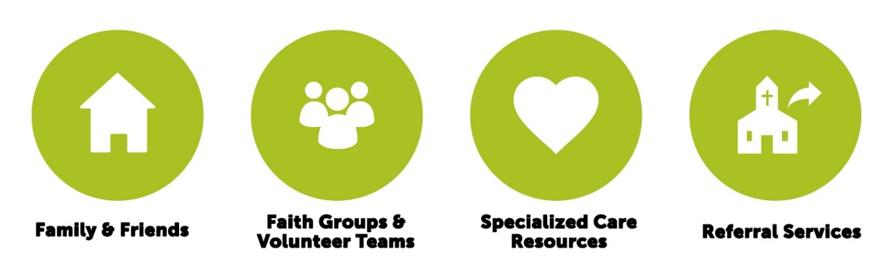

A person with all four circles well developed will be able to face life’s joys and challenges confidently. The level of crisis will determine the impact on the circles. The larger the crisis the more circles the person will draw on and the more they will draw from each circle.

For example, a person receives a new family member through birth. This might receive lots of focus from the family and friends circle; some focus from faith groups and volunteer teams the person is involved in and a congratulations card from our Care and Concern team and maybe meals from their faith group or volunteer team.

However, if the same person experiences a complication with the birth, causing extended hospital stay, and family disequilibrium the person will require more care from these circles. This will include extended, intensive focus from their family and friends circle, a larger involvement from faith groups and volunteer teams in the form of visits, meals, transport services (and more), a visit from our visitation team, prayer services from our urgent prayer list, midweek prayer guide and prayer teams.

Even further, should this same person experience a traumatic birth that results in the death of the infant they will need even more care from these circles. This will include ongoing intensive focus from family and friends; loving, supportive and compassionate care from their faith group and volunteer team; visitation, prayer, initial grief counseling, and a Stephen minister from our Care Ministry teams; and then referrals to ongoing counseling, grief support and other services for crisis care.

The less well developed a person’s circle is, the worse the care support will be; the better developed these circles are the better the care support will be. Different people and different connections develop each of these circles.
The Family and Friend Circle is the responsibility of the individual person to develop. Developing strong friendships and maintaining a good connection with family and friends is the responsibility of the individual. The church can support this by providing avenues and connections for people, but it is the responsibility of the individual to initiate and develop this circle.

The Faith Group and Volunteer Team circle is primarily the responsibility of the individual to develop, but it requires partnership with the church ministries. Faith groups and volunteer teams are prevalent in the church and mechanisms for connecting with these groups are in place. This is the church organization’s responsibility. The person is responsible to engage these mechanisms and commit to these groups. One assumption in this concept is that your involvement in these groups means you are available to support others in need too.

The Specialized Care Ministry Resources Circle is the responsibility of the Care Ministry to develop. We need to discern the right teams to develop, invite the right people to join these teams and regularly evaluate their effectiveness and relevance. These teams are by nature temporary, although their timeframe may be years or decades in existence. Our commitment is not to one team but rather to the biblical concept of care and to the growth of the body of Christ. Teams need to have a key leader, sufficient volunteers and a critical mass of need. These three elements are essential. Healthy teams will also have a leadership development and succession plan in place so they can continue for as long as the congregation needs them.

The Care Ministry Referral Circle is primarily the responsibility of the Care Ministry to develop, but it requires partnership with the individual. The church is responsible for developing access to systems of care for situations that are greater than the first three circles can provide. This includes developing a referral system of resources like therapists, support groups, ongoing counseling, individualized care teams and access to the latest information about prevalent crises. Training of staff and leaders in accessing and using this information is further the responsibility of the Care Ministry. The person is responsible to follow through with the resources made available, discern the right one(s) to use and set up their own connections.

Our Values

Focus: We focus our Care Ministry according to the priorities of Galatians 6:10: “Therefore, as we have opportunity, let us do good to all people, especially to those who belong to the family of believers.”
- Our goal is to facilitate and provide generous care for those who participate in Faith Community Church, grow in their faith and move towards Christlikeness. The Care Ministry will help those outside the church, but not to the detriment of regular attendees and members.
- We believe, healthy members who are Christ-like will reach out to those outside the church in a generous and caring manner.
- When the Care Ministry has developed specialized care ministry groups based on the needs of a critical mass of our congregation, (i.e. Divorce Care, Grief Care, Celebrate Recovery, etc.) these groups may be opened to the communities around us.

Commonality of Care-giving: The Bible states that every believer is a minister of care.
- In a church our size everyone is a guardian of care.
- Church leaders and teachers must be informed of, equipped for and shown how to personally apply this in their relationships with the people in their groups.
- The success of the care proposal and the new philosophy to move towards faith group and personal care systems is heavily dependent on regular, in-depth and consistent training of ministry leaders, faith group leaders, staff and the wider congregation.

Caregivers and care-receivers have an equal relationship based on grace, mutual respect, healthy boundaries and trust.
- This means that care-receivers are not inferior to caregivers, both are equal in Christ.
- Further, this means that caregivers also have needs that require healthy boundaries to guide how and if they can meet the needs of care-receivers.

Stewardship: we will faithfully guard our finances and people entrusted to us.
- Policies, procedures and guidelines enable consistent and fair decision-making.
- A system of checks and balances mitigate risk to the church and the individual receiving care.
- Discernment: we will work responsibly with all people to enable them to become independent while avoiding situations where some could take advantage of the church.

Discipleship is a part of caring.
- As part of our caring interactions with others, we have a commitment towards seeing people take ownership of their lives and their faith and take next steps as disciples.

What do the vision and values mean to you about how we will work as a Church, as a Care Ministry and as an individual member of the ministry?

Our C.A.R.E. Approach

C.A.R.E. Approach
Consider the need in light of care mission and values
Assess the need according to our four circles of care
Refer the need to the appropriate resources
Engage in the power of prayer

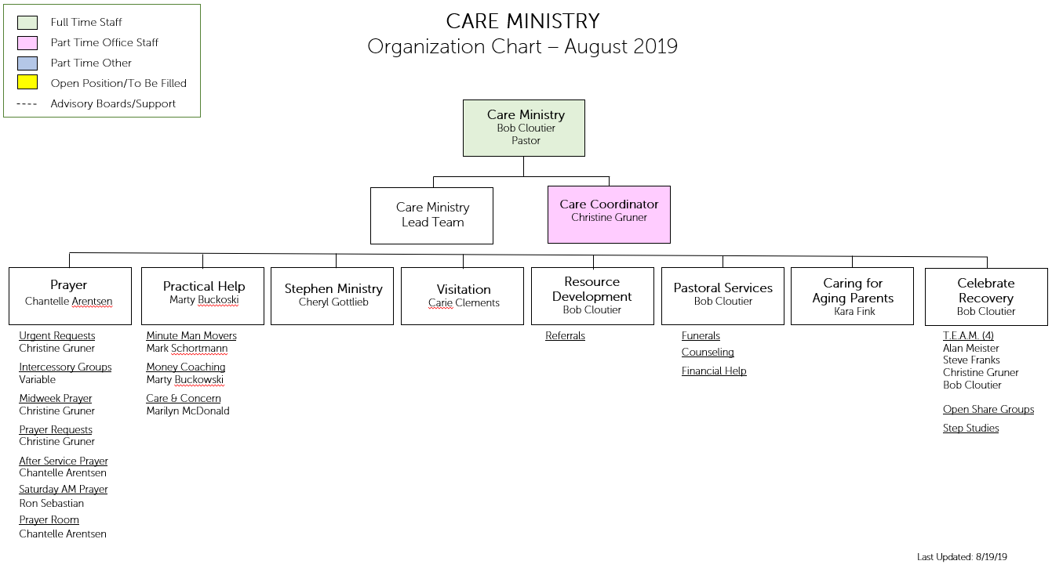
Care Organizational Chart

Specialized Care Teams

You will find a description of our care teams below.

Care & Concern

Description:
Care and Concern recognizes and encourages church members through the use of cards, letters, and gifts at key life events.
Leader Name:
Marilyn McDonald
Ways to Access Team:
Contact the Care Coordinator at 508.435.5900x2883.

Celebrate Recovery Program

Description:
Celebrate Recovery is a biblical and balanced program that helps people overcome hurts, hang-ups, and habits based on the actual words of Jesus. It is a program designed to help those struggling by showing them the loving power of Jesus Christ through a recovery process.
Leader Name:
Bob Cloutier, Care Pastor
Ways to Access Team:
Contact Bob Cloutier at 508.435.5900x2881 or bob@faithma.org.

Minuteman Movers

Description:
Team focuses on helping individuals and families in the church who need additional help with moving needs.
Leader Name:
Mark Schortmann
Ways to Access Team:
Contact the Care Coordinator at 508.435.5900x2883.

Money Management Coaching

Description:
Team focuses on helping people with money management through one-on-one coaching meetings.
Leader Name:
Marty Buckoski
Ways to Access Team:
Contact the office at 508.435.5900x2881 or bob@faithma.org.

Stephen Ministry

Description:
A team of highly trained lay people who provide crisis, follow up, chronic, preventative and/or supportive care for those in need. Their care takes many forms especially listening, prayer, support and encouragement. They participate in supervision regularly to maintain this high quality of care.

The types of care described above are defined as follows:
Crisis care (e.g. a death or divorce)
Follow up care (e.g. weeks and months after a crisis issue)
Chronic care (e.g. extended illness)
Preventative care (e.g. approaching retirement)
Supportive care (e.g. the spouse of someone with a terminal illness)
Leader Name:
Cheryl Gottlieb
Ways to Access Team:
Contact the Care Pastor, Bob Cloutier, at 508.435.5900x2881 or bob@faithma.org.

Visitation Team

Description:
Team focuses on visiting members and regular attendees, in hospital, rehab or at home who are unable to attend.
Leader Name:
Carie Clements
Ways to Access Team:
Contact the Care Coordinator at 508.435.5900x2883.

Other Care Resources

Marriage Mentors

Description:
Marriage Mentors are assigned to engaged couples as part of their pre-marital preparation. They also are available to help the couple in the early months of their new relationship.
Leader Name:
Rob Stadolnik
Ways to Access Team:
Contact Rob Stadolnik at firepsych@comcast.net.

Elders Compassion Fund

Description:
The Elders Compassion Fund is a fund established to permit receipt of tax-deductible donations from individuals within the congregation for the purpose of helping needs or projects that are consistent with Faith Community Church’s tax exempt purposes, including charitable relief of the poor, distressed and/or underprivileged (collectively, the “needy”).
Leader Name:
Elders (coordinated by Pastoral Staff)
Contact Details:
Contact the Care Pastor, Bob Cloutier, at 508.435.5900x2881 or bob@faithma.org.

Referral System

Description:
Faith Community has an extensive database of mental health, legal, financial and social service professionals in the New England area.
Leader Name:
Bob Cloutier
Ways to Access:
Contact the Care Coordinator at 508.435.5900x2883.

Special Note: We do not refer people to specific professionals. Rather, we provide a list of professionals in the area requested. It is up to the person making the request to determine which professional they want to contact for help. We do provide a tool to help make that selection.

Pastoral Services

Description:
To receive church family* services of a pastor for funerals, short-term counseling and/or referrals.
Leader Name:
Bob Cloutier, Care Pastor
Ways to Access:
Contact Bob Cloutier at 508.435.5900x2881 or bob@faithma.org.

*Church family
refers to attendee of Faith Community Church and immediate family member (mother, father, spouse, siblings, children)

Prayer Resources

Prayer Requests

Description:
Any prayer can go on this list for family or friends.
Group Receiving Request:
Prayer Request Team
Coordinator:
Verla Bennie
Ways to Access:
Submit prayer requests through the Live Event, online at faithma.org/prayer, fill out a prayer request card on Sunday at services or send special requests to this group as needed by contacting the office Care Line at 508.435.5900x2883.

Sunday Prayer Ministers

Description:
Pray with people after Sunday services.
Coordinator:
Chantelle Arentsen
Ways to Access:
Contact the Care Pastor, Bob Cloutier, at 508.435.5900x2881 or bob@faithma.org.

Urgent/Crisis Needs Prayer List

Description:
For use by church family* only for a life threatening situation, death
announcement, or significant, imminent event such as surgery.
Group Receiving Request:
Urgent/Crisis Needs Prayer Team
Coordinator:
Verla Bennie
Ways to Access:
Contact the Care Line at 508.435.5900x2883.

*Church family
refers to attendee of Faith Community Church and immediate family member (mother, father, spouse, siblings, children)

Midweek Prayer Guide

Description:
Critical care needs of church family* sent out on Tuesday
Group Receiving Request:
Midweek Prayer Group
Coordinator:
Verla Bennie
Ways to Access:
Contact Care Coordinator, 508.435.5900x2883.

Note: For ongoing listing, we ask the recipients to provide us with updated information.

Church Intercessory Prayer Groups

Wednesday Morning prayer group
Time: 7 – 8am
Open to anyone
Contact person: Pastor Bob Cloutier

Other Prayer Groups

There are other prayer groups within each ministry.

For example,
Men’s Prayer Breakfast
Student Ministry
Children’s Ministry

Contact the appropriate ministry for details.

*Church family
refers to attendee of Faith Community Church and immediate family member (mother, father, spouse, siblings, children)

Foundational Tools

We want you to take away some practical tools and resources to put into practice the caring we have been talking about in this packet. Foundational tools to care involve the best resources we have at our disposal as Christians: prayer and Scripture. Let us examine some of the best ways to pray for each other and to use Scripture in the context of caring for someone in need.

Prayer

We are all ministers of care so we can all pray for one another.

How do we pray for one another?

- Use the available avenues of prayer:
  - Friends and family
  - Faith groups/volunteer teams
  - Prayer Request Cards
  - Electronic Prayer Request
  - After service prayer
  - Midweek prayer guide
  - Urgent prayer team
  - Intercessory teams
- Be approachable with your body language
  - Welcoming
  - Open
  - Relaxed
  - Keep eye contact without being predatory
  - Smile with your eyes
- Listen well
  - Listen to the person
    - Ask questions to define what they are saying.
    - Pay attention to their body language
    - Discern what they are not saying.
  - Listen to the Spirit
    - What is the Spirit telling you?
    - What prompts, insights or revelations might you be hearing?
    - What words of Scripture come to mind?
  - Listen to yourself
    - Use common sense about time, requests, and space
    - What do you feel?
    - What do you connect with appropriately?

- Touch when appropriate
  - Ask permission
  - Use discretion
  - Use warmth
  - Use modesty
  - Use compassion
- Use scripture when appropriate
  - Be relevant
  - Be encouraging
  - Be clear
  - Be brief
- Pray
  - Be Christ focused
  - Be clear
  - Be direct
  - Be succinct
  - Be gracious
  - Be encouraging
  - Be natural
  - Be sensitive
- Take notes for follow up
  - Name of person
  - Prayer request
  - Follow up and redirection

Scripture

We are all ministers of care so we can all use Scripture to help others.
- Know your Scriptures
  - Daily devotions
  - Memorization
  - Meditation
  - Application
- Use available resources
  - Scripture booklet
  - Bible Promises for You book
  - Sermons
- Read passage
  - Choose 1 or 2
  - Read clearly
  - Read with emotion
  - Use eye contact
  - Read relevant passages
  - Keep it short
- Share why your read that Scripture
  - Don’t preach
  - Be encouraging
  - Be Christ-focused
  - Avoid controversial topics
- Be in line with our doctrines
- Close the reading with prayer
  - See prayer outline above.

Next Steps

Now that you have worked through this packet you have the introductory training to join a care team. These teams offer and require additional training, but this foundation sets you up to know what we do and how some do it.

Because of this workbook, we invite you to commit to one or more of the following next steps.

- Fill out a care ministry application form.
- Join our prayer ministry team.
  - The Sunday prayer ministry team is a group of people available and willing to pray for others in our church, especially after services.
  - You can join by contacting the Care Ministry in the office.
  - You will receive a name badge that you can wear to make yourself known to those looking for prayer after services.
  - Each Sunday, as you are available, wear your name badge, proceed to the front of the worship venues during the benedictions and be available to pray for those in need. There is no roster or coordination, follow the prompts of the Spirit and be obedient and available as you have strength.
  - Pass on notes and follow up material to the Care Ministry.
- Consider one of our care teams if you are not in one.
  - Speak with the Pastor of Care about where best to serve more intentionally.
  - It is ok to try them out
  - You may not qualify for some.
- Become a member of Faith Community Church
- Invite others to join our ministry.
  - You know what we are doing, so share our vision with others.
  - Make copies of this introduction for others to learn about us.
  - Recommend people to us, but speak to them first.

Thank You

Thank you for considering and joining our ministry. As we serve together my prayer as the Pastor of Care is that you will be effective and productive as you walk alongside others in their time of need. As you make yourself available, my hope is that your work will challenge and transform you into ever-deeper Christlikeness and greater love for others.

Your work is important, so work with faithfulness, serve with diligence and care with compassion. Together we will achieve our mission of equipping leaders and caring for regular attendees.

Thank you again and God bless you as you serve.

His divine power has given us everything we need for a godly life through our knowledge of him who called us by his own glory and goodness. Through these he has given us his very great and precious promises, so that through them you may participate in the divine nature, having escaped the corruption in the world caused by evil desires. For this very reason, make every effort to add to your faith goodness; and to goodness, knowledge; and to knowledge, self-control; and to self-control, perseverance; and to perseverance, godliness; and to godliness, mutual affection; and to mutual affection, love. For if you possess these qualities in increasing measure, they will keep you from being ineffective and unproductive in your knowledge of our Lord Jesus Christ.
2 Peter 1:3-8

Blessings,
Bob Cloutier
Pastor of Care Ministry

Care Ministry Application

Date:

Name:
(last name) (first) (middle)

Address:
(Street) (Apt. #)

(Town) (State) (Zip)

Email:

Phone Number: Birthdate:

1. Are you a believer? Yes No

3. Have you participated in the SHAPE Workshop? Yes No

4. Please list your top 3 spiritual gifts if known.

5. Please list or describe your passions.

6. Please circle your personal style.
Task Structured Task Unstructured People Structured People Unstructured

7. Please list areas of interest within the Care Ministry.

146 East Main Street |
Hopkinton | MA | 01748
Phone 508.435.5900
Fax 508.435.3890
www.faithma.org

